**Exercise 1: Control Structures**

**Scenario 1: Discount Interest Rate for Customers Over 60**

DECLARE

CURSOR cur_senior_customers IS

SELECT c.CustomerID, l.LoanID, l.InterestRate

FROM Customers c

JOIN Loans l ON c.CustomerID = l.CustomerID

WHERE MONTHS_BETWEEN(SYSDATE, c.DOB) / 12 > 60;

BEGIN

FOR rec IN cur_senior_customers LOOP

UPDATE Loans

SET InterestRate = InterestRate - 1

WHERE LoanID = rec.LoanID;

END LOOP;

COMMIT;

END;

/

Output:

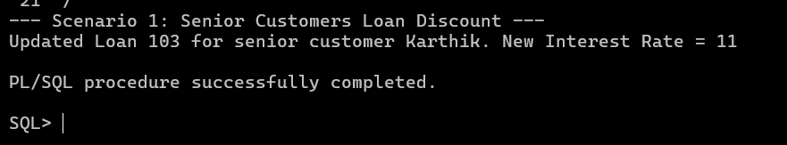

**Scenario 2: Set IsVIP Flag for High Balance Customers**

BEGIN

DBMS_OUTPUT.PUT_LINE('--- Scenario 2: VIP Customer Update ---');

FOR rec IN (

SELECT CustomerID, Name, Balance

FROM Customers

WHERE Balance > 10000

) LOOP

UPDATE Customers

SET IsVIP = 'TRUE'

WHERE CustomerID = rec.CustomerID;

DBMS_OUTPUT.PUT_LINE('Customer ' || rec.Name || ' marked as VIP (Balance: ' || rec.Balance || ')');

END LOOP;

COMMIT;

END;

/   
  
  
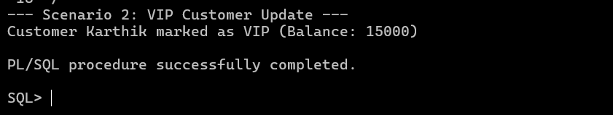

**Scenario 3: Reminders for Loans Due in Next 30 Days**

BEGIN

DBMS_OUTPUT.PUT_LINE('--- Scenario 3: Loan Due Reminders ---');

FOR rec IN (

SELECT l.LoanID, l.EndDate, c.Name

FROM Loans l

JOIN Customers c ON l.CustomerID = c.CustomerID

WHERE l.EndDate BETWEEN SYSDATE AND SYSDATE + 30

) LOOP

DBMS_OUTPUT.PUT_LINE('Reminder: Loan ID ' || rec.LoanID ||

' for customer ' || rec.Name ||

' is due on ' || TO_CHAR(rec.EndDate, 'DD-MON-YYYY'));

END LOOP;

END;

/

Output:

